Acct 2210 Zeigler: AQ #2 Solution – Spr 2015 (Chp 3) - 15 pts
Review for Exam #2 – See me or our GA team with any questions

____ 1. From our Chp 3 Online practice quiz, the recording rules of double-entry accounting (related to assets, liabilities, and stockholders' equity accounts) can be summarized as:
a. Debits increase asset accounts; credits decrease liability and stockholders' equity accounts.
b. Debits decrease asset accounts; credits increase liability and stockholders' equity accounts.
c. Debits increase asset accounts; credits increase liability and stockholders' equity accounts.
d. Debits decrease asset accounts; credits decrease liability and stockholders' equity accounts.

____ 2. From our Chp 3 Online practice quiz, which of the following best describes where you would find a chronological record of business transactions recorded in the accounting records?
a. The General Ledger
b. A Chart of Accounts
c. The General Journal
d. A Trial Balance

____ 3. Adjusting entries are made at the end of the accounting period because of the need to:
a. adjust the balance in the Cash account for the effects of transactions with customers & creditors.
b. adjust the Retained Earnings account directly.
c. prepare revenue and expense accounts for recording transactions in the next accounting period by bringing the balances to zero.
d. assure that revenues and expenses are recognized in the period in which they are earned or incurred.
_____4. LeGalley Company uses accrual-basis accounting and performs accounting services for Olenik Company. Upon completion, LeGalley sends Olenik a bill and records revenue on its books, despite having received no cash from Olenik. For LeGalley, this is an example of:
a. a deferred expense.
b. an unearned revenue.
c. an accrued expense.
d. an accrued revenue (i.e. revenue earned on account)

_____ 5. Little, Smith & Muniak, Inc. signed a $10,000 note payable to USGB Bank on April 1, 2014. The note had a 3 percent annual interest rate and a one-year term. Which of the following general journal entries would be necessary to record accrued interest on December 31, 2014?
a. Interest Expense $225
Interest Payable $225 (10,000 * .03 * 9/12 = $225)
b. Interest Payable $225
Interest Expense $225
c. Interest Expense $ 75
Interest Payable $ 75
d. Interest Payable $ 75
Interest Expense $ 75
Note: The company is borrowing from the bank here, issuing a “Promise” to pay the loan back at maturity. This is properly called a “Note Payable” or “Promissory Note”.

_____ 6. Gorman & Brousseau, Inc. pays its employees on the 1st and the 15th of each month after the pay has been earned. The company’s employees had earned $8,725 in salaries during the pay period ending December 31st. What adjusting journal entry does the company need to make to
record the accrued salaries on its December 31st financial statements?

a. Salaries Payable 8,725
Cash 8,725
b. Salaries Expense 8,725
Salaries Payable 8,725
c. Salaries Expense 8,725
Cash 8,725
d. Salaries Payable 8,725
Salaries Expense 8,725

_____ 7. The unadjusted Trial Balance for Trippodo & Butler, Inc. indicates that they have $3,250 of supplies on hand. A physical count at year-end, however, revealed that they only have $750 of supplies remaining. What adjusting journal entry must be made at the end of the year?
a. Supplies Expense 750
Supplies 750
b. Supplies 750
Supplies Expense 750
c. Supplies Expense 2,500
Supplies 2,500
d. Supplies 2,500
Supplies Expense 2,500

_____ 8. The international firm of Le Naitre & Midhiff, Inc. recorded the following transaction:
Cash |  |  | Unearned Revenue
5,000 |  |  |  | 5,000
Which of the following reflects how this event would affect their company financial statements?
- Both revenues and assets would increase.
- Assets would decrease. (assets would increase)
- Retained Earnings would increase. (no effect from this transaction)
- Cash flow from Investing activities would be increased. (no, this would be an Operating Activity)
- Liabilities would increase.
We have not earned anything yet (a classic “Deferral” here). When we do earn the revenue, it will be recognized on the Income Stmt. Only a liability is created at this point.

_____ 9. If a company fails to make an adjusting entry to record previously “unearned revenue”
that has now been earned, then:
a. assets will be understated. (no effect)
b. retained earnings will be understated. (earned Revenue is too low, thus Net Inc is too low)
c. expenses will be overstated. (no effect)
d. liabilities will be understated. (liabilities would be too high/overstated)

_____ 10. Eby, Burgess & Bronne, Inc. paid and properly recorded prepaid rent for one year in the amount of
$24,000 on September 1st. When the company prepared its year-end financial statements on December
31st, what adjusting entry would be required?
a. Rent Expense 16,000
Prepaid Rent 16,000
b. Prepaid Rent 8,000
Rent Expense 8,000
c. Rent Expense 8,000
Prepaid Rent 8,000
d. Prepaid Rent 16,000
Rent Expense 16,000

_____11. Tuttle & Catherine, Inc. offers quality tutoring services to discriminating students. At the end of
their accounting period, which of the following journal entries shows “Service Revenue” being “closed”?
a. Retained Earnings XX
Service Revenue XX
b. Service Revenue XX
Common Stock XX
c. Unearned Revenue XX
Service Revenue XX
d. Service Revenue XX
Retained Earnings XX
* Use the following Information for questions 12 – 14 *
Henry & Cox, Inc. presented its 12/31/14 Income Statement and Balance Sheet as shown below:
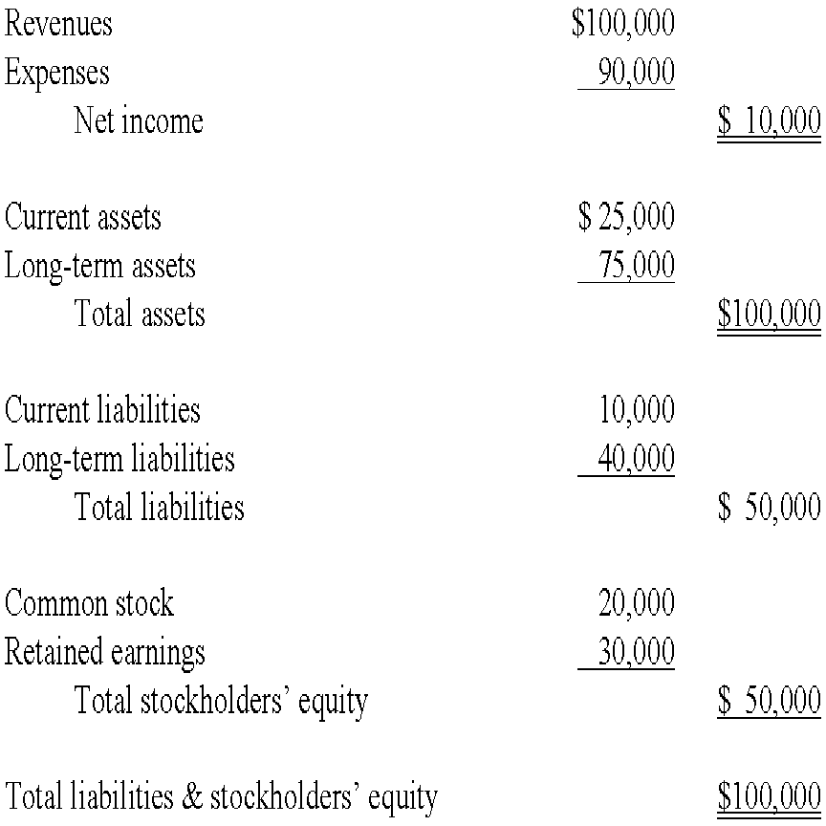

_____ 12. The company’s total “Debt-to-Assets” ratio is:
a. 5%.
b. 10%.
c. 20%.
d. 50%.
e. None of the above.

_____ 13. The company’s “Return on Assets” (ROA) ratio is:
a. 5%.
b. 10%.
c. 20%.
d. 50%.
e. None of the above.

_____ 14. Based upon the information presented, the company’s Return on Equity (i.e. ROE) would:
a. be higher than ROA.
b. be lower than ROA.
c. be the same percentage as ROA.

---------------------------------------------------------------------------------------------------------------------

_____ 15. Tucker, Salata & Harris, Inc. collected $4,000 in cash that was due on an account receivable. The Company’s accounting intern recorded the entry as a debit to cash and a credit to service revenue. As a result of this error, the intern was required to attend office-hours and re-read Chapter 3! What would be the effect of this error on the financial statements?
a. total liabilities would be overstated. (no effect)
b. the amount of cash will be overstated. (no, cash balance would still be correct)
c. total revenues will be overstated. (yes, revenues overstated = recorded twice)
d. the totals of the trial balance will not be equal. (no, debits still equal credits)
e. total stockholder’s equity would be understated. (no, overstated)

Optional (Non-Graded) Bonus Questions if you have the time (No points)

Use the following for questions 16 & 17:
Zeigler Academics, Inc. had the following Adjusted Trial Balance on December 31, 2014.

Dr. Cr.
Cash (PERMANENT ACCT) 84,155
Accounts Receivable 32,500
Prepaid Rent 3,600
Land 92,000
Accounts Payable 9,735
Unearned Revenue 12,465
Note Payable 67,800
Common Stock 50,000
Retained Earnings 43,675
Dividends 14,000
Service Revenue 83,955
Wages Expense 23,500
Utility Expense 1,200
Rent Expense 10,100
Advertising Expense 5,200
Miscellaneous Expense 1,375
$267,630 $267,630

_____ 16. After any/all necessary closing entries have been made, the company Cash account balance would be:
- $84,155 (Closing entries will have no effect on cash – we are closing temporary accounts to R/E)
- $72,255
- $43,675
- $267.630
- Negative.

17. Prepare a Balance Sheet in GOOD FORM that would result after all closing entries have been made.
Zeigler Academics, Inc.
Balance Sheet (Post-Closing)
For the Year Ended December 31, 2014
Assets: |  | Liabilities:
Cash | 84,155 | Accts Payable | 9,735
Accts Receivable | 32,500 | Unearned Revenue | 12,465
Prepaid Rent | 3,600 | Note Payable | 67,800
Land | 92,000 | Total Liabilities  (Subtotal) | 90,000
 |  | Stockholders Equity:
 |  | Common Stock | 50,000
 |  | Retained Earnings (Updated after all  Closing Entries) | 72,255
 |  | Total Equity | $122,255
Total Assets: | $212,255 | Total Liab + Equity | $212,255

Good Review for Exam #2 – See me or our GA team with any questions

