Acct 2220 Zeigler: Chp 10 Time Value of Money Factor Tables (see pg 320/321)
Use these tables to “discount” future cash flows back to today. In essence, you are “stripping away” (i.e. deducting) interest at your required rate of return.

Table 1: Use for single cash flows. Formula: 1 / (1 +i)^n HANDOUT #1
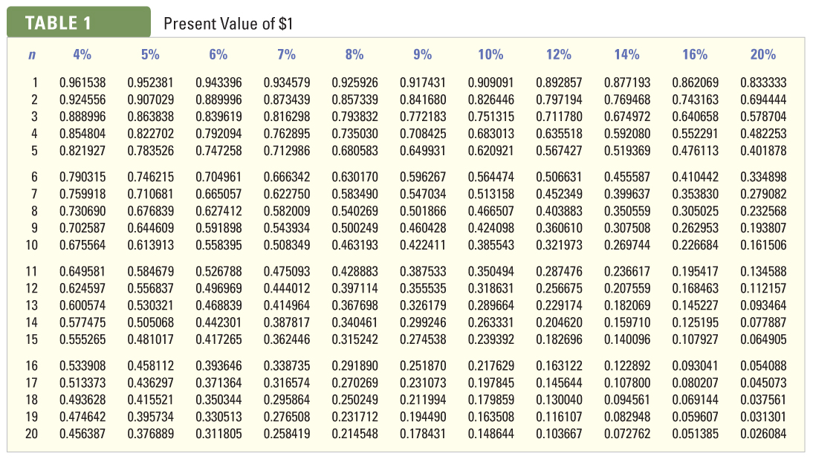
Table 2: Use for multiple, equal cash flows. Formula: 1 / i [1 – (1 / (1+i)^n ]
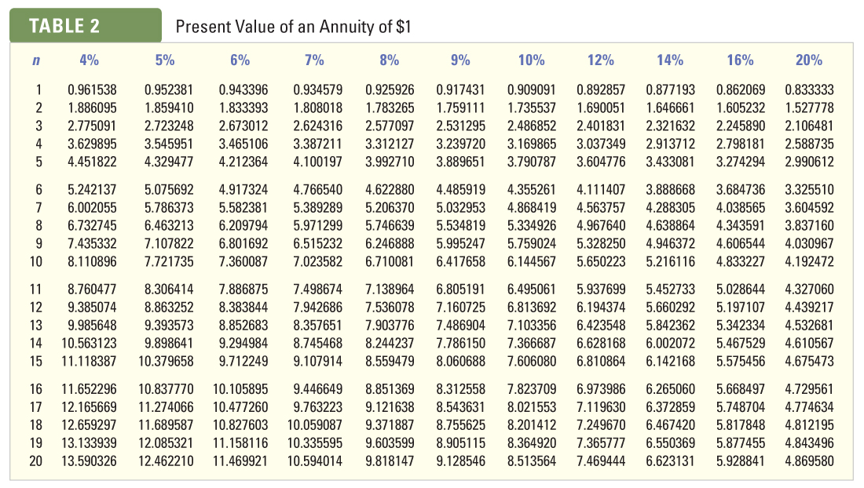
Notes:
1) Table 2 assumes a stream of equal cash flows at the end of each period.
2) Table 2 is for “convenience” and is not required. When in doubt, use Table 1.
3) Table 2 is also known as an “Ordinary Annuity” or “Annuity in Arrears” table because the cash flows are deemed to take place at the end of the period. For cash flows that take place at the beginning of the period, you would; a) subtract one period, and b) add 1.0 to the factor found on the table above. This is known as an “Annuity Due” or “Annuity in Advance”. We will only work with Ordinary Annuities.
HANDOUT #2

Acct 2220 Zeigler: Chapter 10 Three “Key Formulas”
Time Value of Money is all about Cash flows…

Key Formula #1: To determine today’s value (PV) of future cash receipt(s). See Pg 304 example:

Formula: Amount of each future receipt * Present Value Factor from:

Table 1: If a single sum, or
Table 2: If multiple equal sums are involved
Issue: “What is today’s value of some future cash receipts?” Does today’s value of future cash receipts exceed my investment today, given my required rate of return?

Key Formula #2: To determine Present Value (IRR) factor. See Pg 308 for an example:

Formula: Required Investment / Periodic cash receipt

-The result is a factor for determining Internal Rate of Return. After calculating the factor, you then refer to the number of periods in the appropriate PV table to find the “exact” (close approximate) rate of return by finding the intersection of the factor and the number of periods involved.
Issue:”What is the exact rate of return I will be earning?” The use of IRR compliments NPV analysis. Where NPV simply indicates whether a particular rate of return will be earned (“hurdled”), IRR attempts to indicate the exact rate of return the investment will offer.

Key Formula #3: To determine the Periodic Receipt(s) required
(This is not in the text, but we will cover in class):

Formula: Required Investment / Present Value Factor

- This calculation will provide the amount of the periodic cash flow required to obtain the desired rate of return (usually an annuity from Table 2).
Issue: What benefit (cash flow) per period is required to earn a particular rate of return?

----------------------------------------------------------------------------------------------------
Relationships among the Three Key Formulas:
Related elements among the formulas:

- Investment (Cash outflow required today)
- PV table factor (based upon the discount rate used)
- Future cash flow(s) related to the investment

Key Formula #1 (Present Value calculation):
B x C = A (PV of the future cash flows). This is today’s value of a future cash flow(s).

Key Formula #2: IRR: What “actual” rate will being earned?
A / C = B (a Table Factor). Now, find the rate by looking up the factor computed.

Key Formula #3: Periodic Future Cash Flow (benefit) required to achieve a particular rate of return:
A / B = C (Required Periodic Cash Flow). This is the periodic cash flow required per period to earn the desired rate of return.

